**Case Study CarConnect**

**C-Sharp, MSSQL and Testing NUnit**

**Introduction:**

CarConnect is a console-based car rental management system developed using C# and SQL Server. The application follows a layered architecture and demonstrates best practices in software engineering, including service abstraction, robust exception handling, and structured testing. It enables seamless management of customers, vehicles, and reservations through an intuitive menu-driven interface.

**Technologies & Tools Used:**

| **Category** | **Stack/Tool** |
| --- | --- |
| **Language** | C# (.NET 8.0) |
| **Framework** | .NET Console Application |
| **Database** | Microsoft SQL Server |
| **Database Access** | ADO.NET |
| **IDE** | Visual Studio 2022 |
| **Testing Framework** | NUnit |
| **Version Control** | Git & GitHub |

**Project Structure:**

* CarConnectApp/
* Dao/
  + Implementations – database operation logic
  + Interfaces – DAO contracts
* Entity/ – model classes (Customer, Vehicle)
* Exceptions/ – custom exception handling
* Service/
  + Implementations – business logic
  + Interfaces – service contracts
* Util/ – DB utility and connection
* *CarConnectApp.csproj* – main project file
* *Program.cs* – application entry point
* CarConnectApp.Tests/
* CustomerServiceTests.cs
* ReservationServiceTests.cs
* VehicleServiceTests.cs
* AdminServiceTests.cs
* CarConnectApp.Tests.csproj – test project file

**Key Highlights:**

* Modular, extensible architecture with separation of concerns
* Clean database interaction using ADO.NET
* Built-in unit tests with NUnit for business logic reliability
* Easy to set up and run with SQL Server and Visual Studio

**SQL Queries:**

**Create Database and Tables**

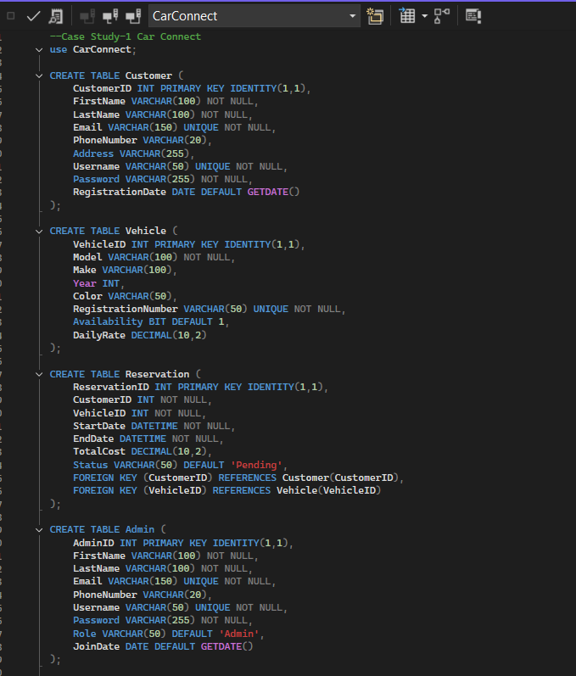

**Insert the values into the Table**

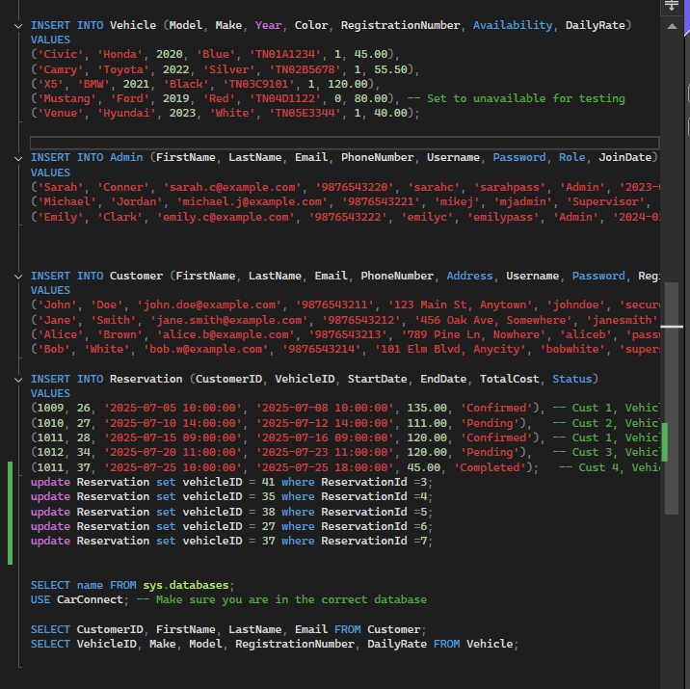

**View the Table**

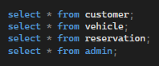

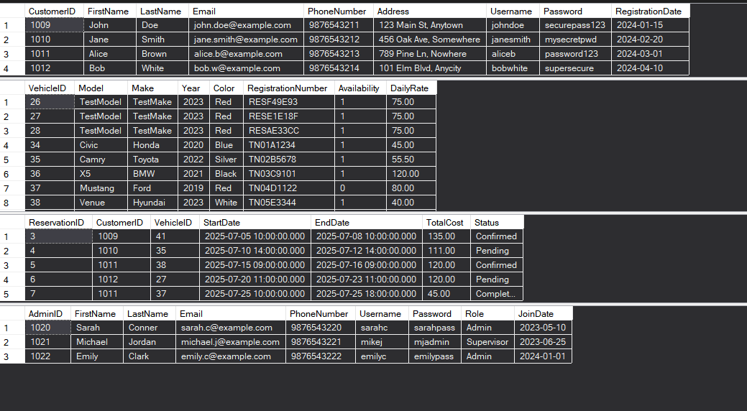

**Entity/Admin.cs**

using System;

using System.Collections.Generic;

using System.Linq;

using System.Text;

using System.Threading.Tasks;

namespace CarConnectApp.Entity

{

public class Admin

{

public int AdminID { get; set; }

public string FirstName { get; set; }

public string LastName { get; set; }

public string Email { get; set; }

public string PhoneNumber { get; set; }

public string Username { get; set; }

public string Password { get; set; }

public string Role { get; set; }

public DateTime JoinDate { get; set; }

public Admin() { }

public Admin(int adminID, string firstName, string lastName, string email, string phoneNumber,

string username, string password, string role, DateTime joinDate)

{

AdminID = adminID;

FirstName = firstName;

LastName = lastName;

Email = email;

PhoneNumber = phoneNumber;

Username = username;

Password = password;

Role = role;

JoinDate = joinDate;

}

public bool Authenticate(string password)

{

return Password == password;

}

}

}

**Entity/Customer.cs**

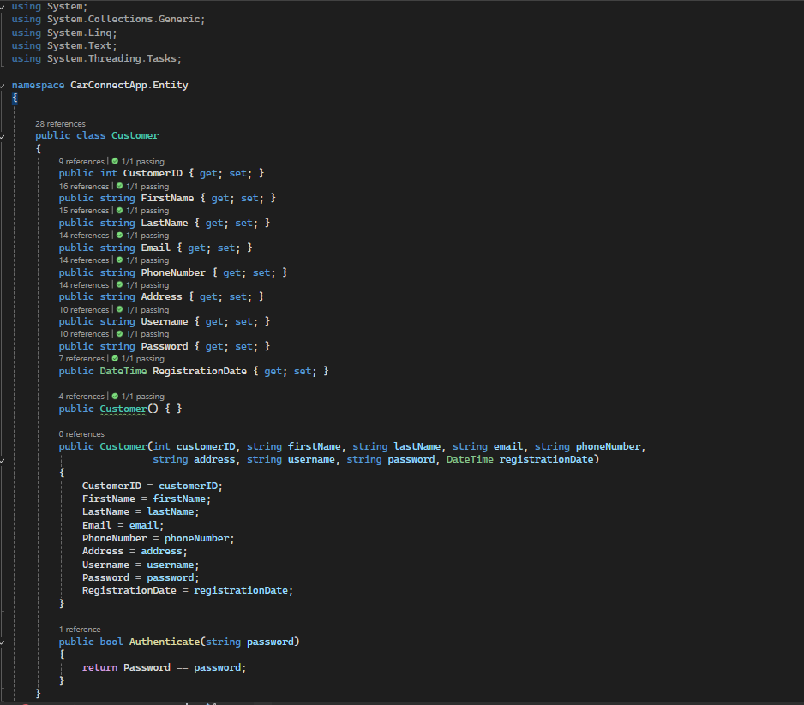

**Entity/Vehicle.cs**

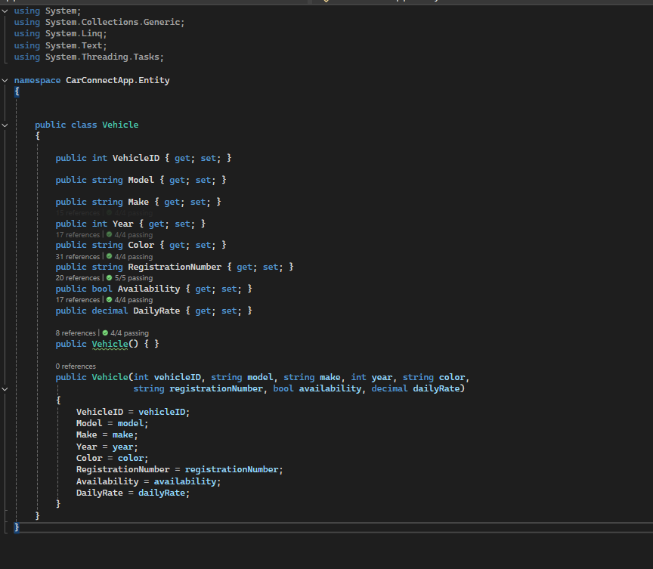

**Entity/Reservation.cs**

using System;

namespace CarConnectApp.Entity

{

public class Reservation

{

public int ReservationID { get; set; }

public int CustomerID { get; set; }

public int VehicleID { get; set; }

public DateTime StartDate { get; set; }

public DateTime EndDate { get; set; }

public decimal TotalCost { get; set; }

public string Status { get; set; }

public void CalculateTotalCost(decimal dailyRate)

{

TimeSpan duration = EndDate - StartDate;

TotalCost = (decimal)duration.TotalDays * dailyRate;

}

}

}

**Dao/Interfaces/IAdminService.cs**

using CarConnectApp.Entity;

namespace CarConnectApp.Dao.Interfaces

{

public interface IAdminService

{

void AddAdmin(Admin admin);

Admin GetAdminById(int id);

Admin GetAdminByUsername(string username);

void UpdateAdmin(Admin admin);

void DeleteAdmin(int id);

}

}

**Dao/Interfaces/ISustomerService.cs**

using CarConnectApp.Entity;

namespace CarConnectApp.Dao.Interfaces

{

public interface ICustomerService

{

void RegisterCustomer(Customer customer);

Customer GetCustomerById(int id);

Customer GetCustomerByUsername(string username);

void UpdateCustomer(Customer customer);

//void DeleteCustomer(int id);

void DeleteCustomer(int customerId);

}

}

**Dao/Interfaces/IVehicleService.cs**

using System.Collections.Generic;

using CarConnectApp.Entity;

namespace CarConnectApp.Dao.Interfaces

{

public interface IVehicleService

{

void AddVehicle(Vehicle vehicle);

Vehicle GetVehicleById(int vehicleId);

List<Vehicle> GetAvailableVehicles();

void UpdateVehicle(Vehicle vehicle);

void RemoveVehicle(int vehicleId);

Vehicle GetVehicleByRegistrationNumber(string registrationNumber);

}

}

**Dao/Interfaces/IReservationService.cs**

using System.Collections.Generic;

using CarConnectApp.Entity;

namespace CarConnectApp.Dao.Interfaces

{

public interface IReservationService

{

void BookReservation(Reservation reservation);

Reservation GetReservationById(int reservationId);

List<Reservation> GetReservationsByCustomerId(int customerId);

void CancelReservation(int reservationId);

}

}

**Dao/Implementations/AdminService.cs**

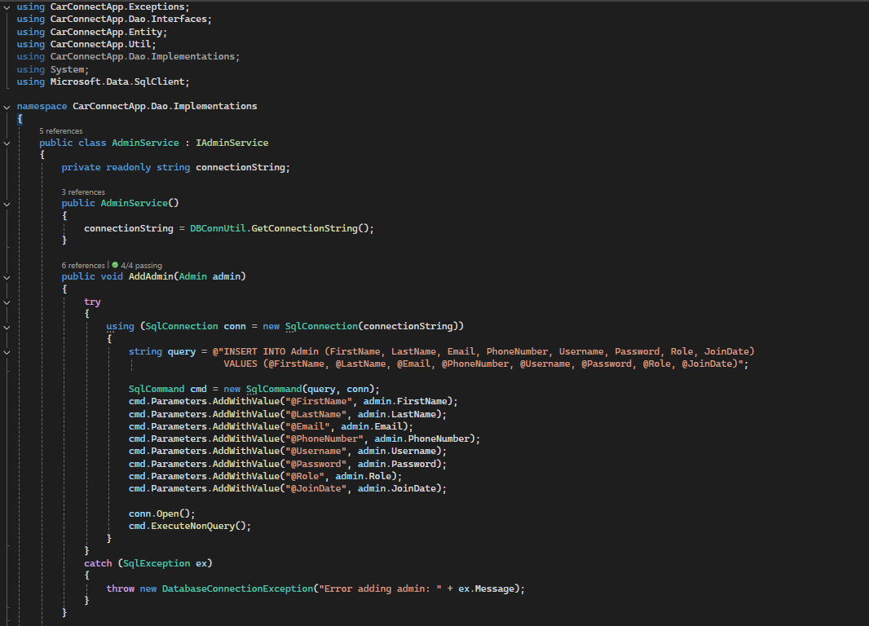

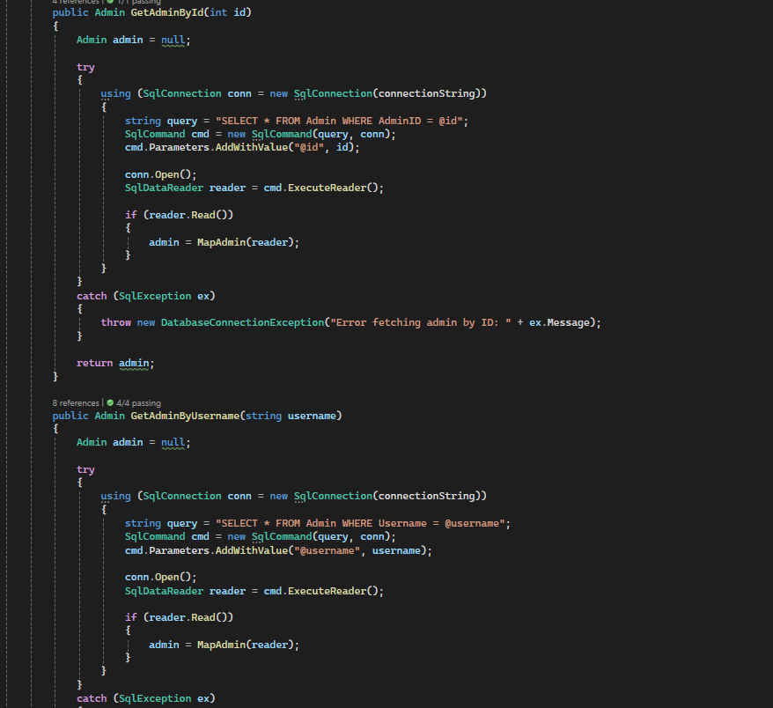

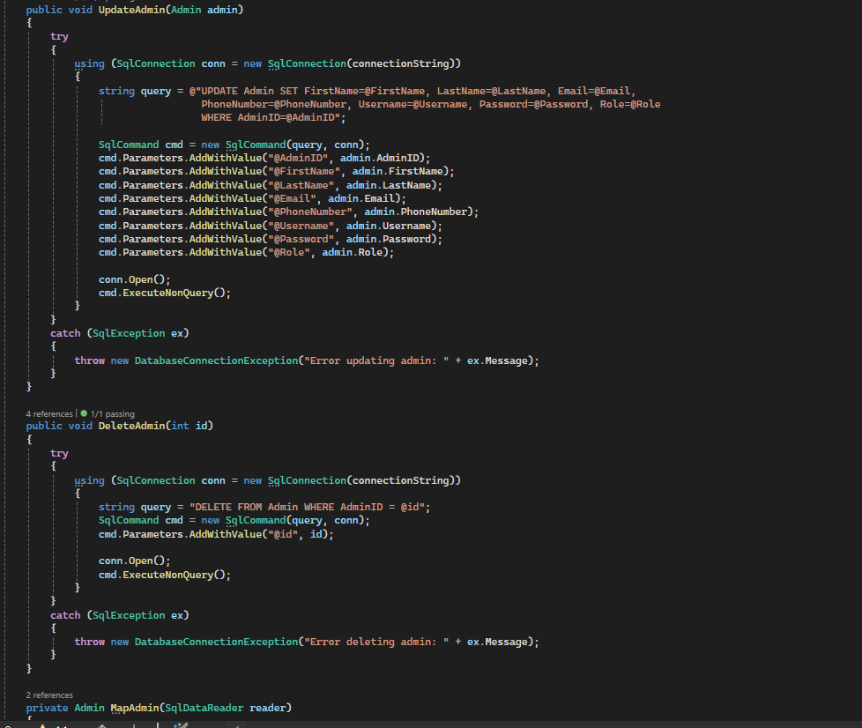

**Dao/Implementations/CustomerService.cs**

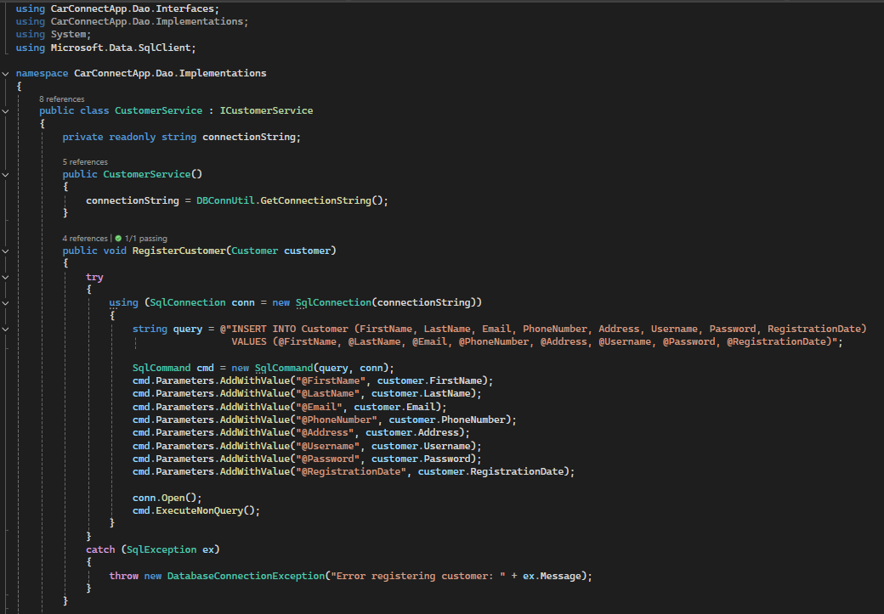

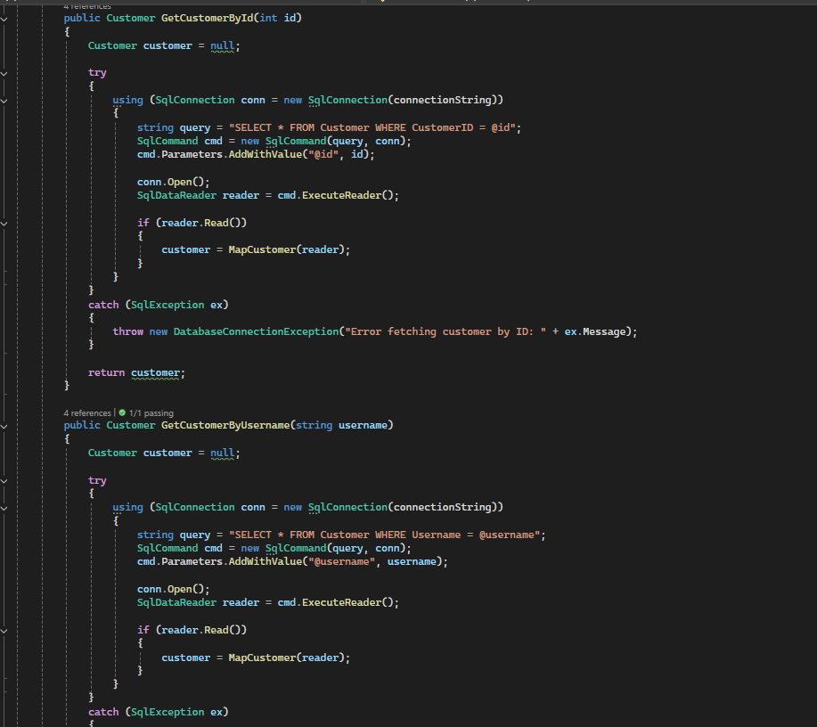

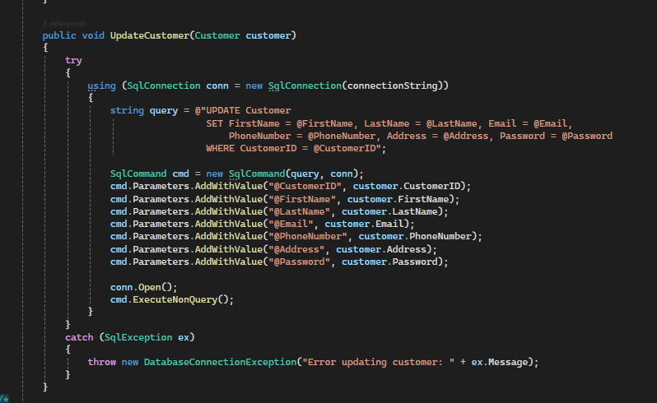

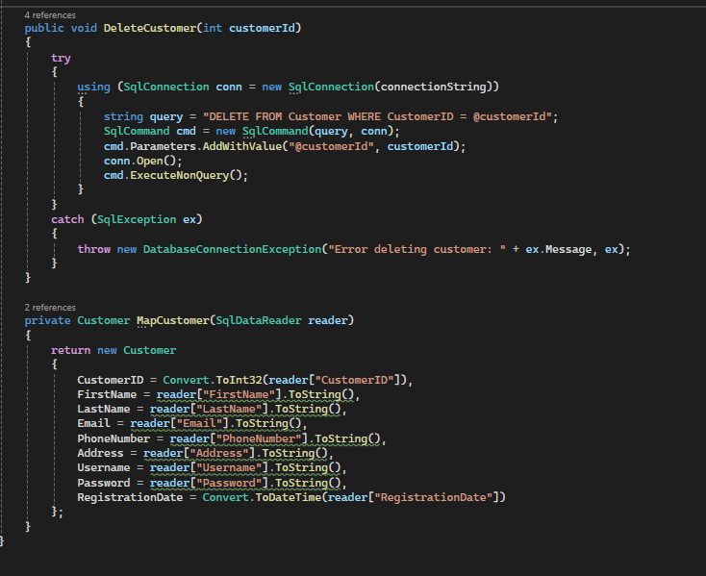

**Dao/Implementations/VehicleService.cs**

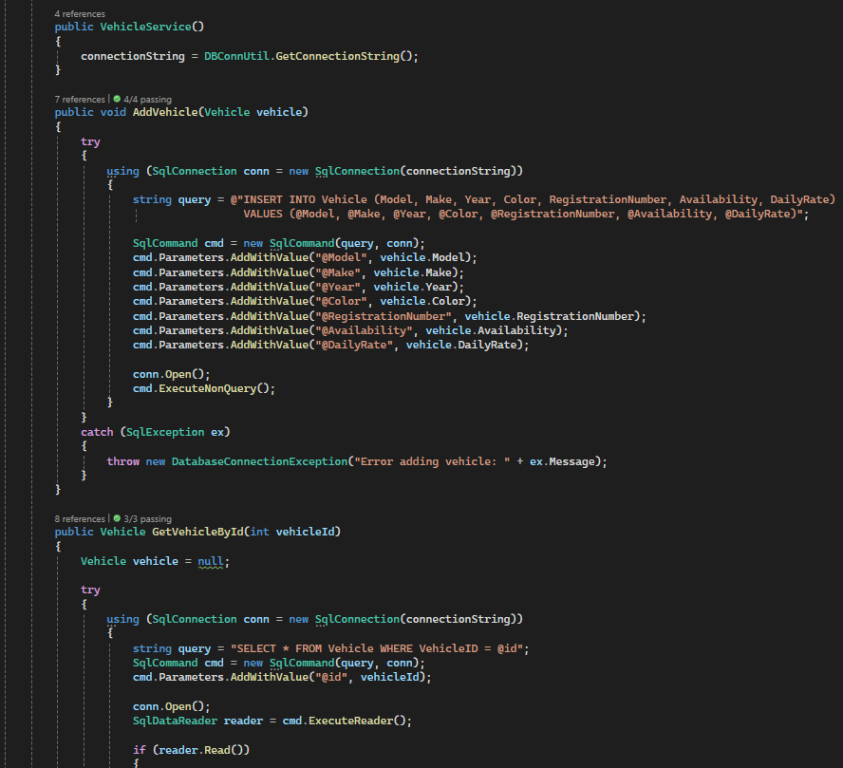

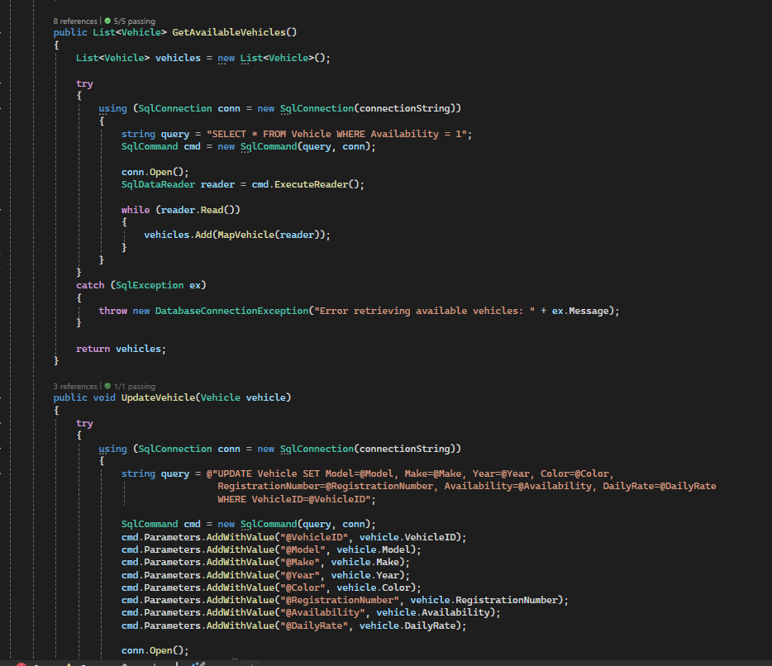

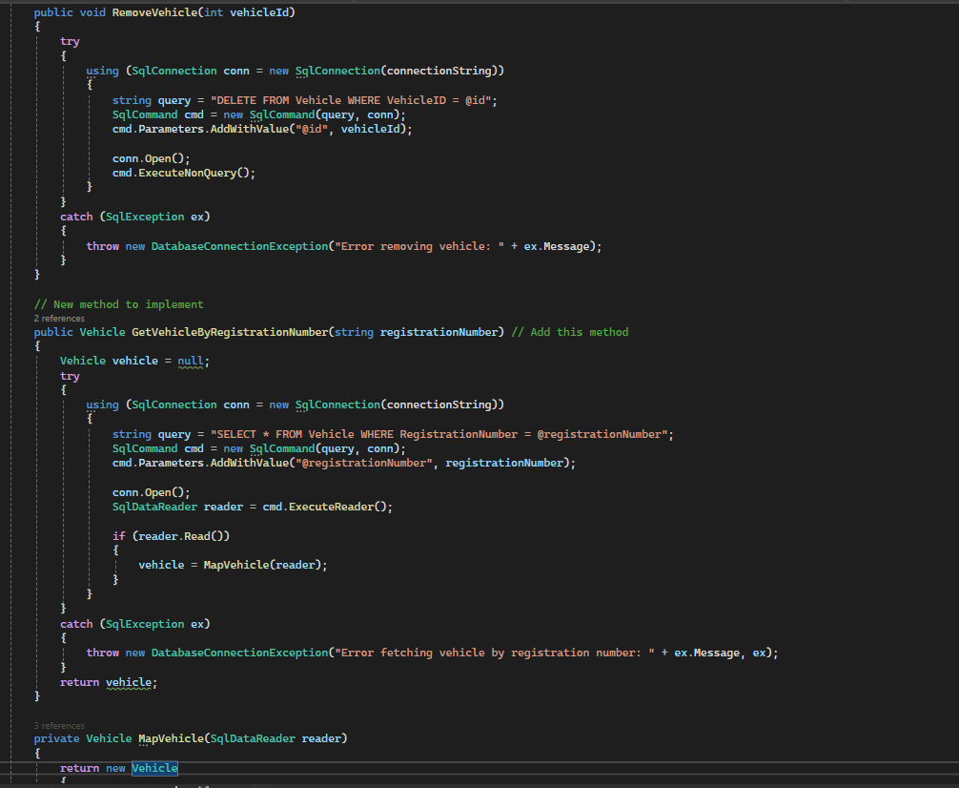

**Dao/Implementations/ReservationService.cs**

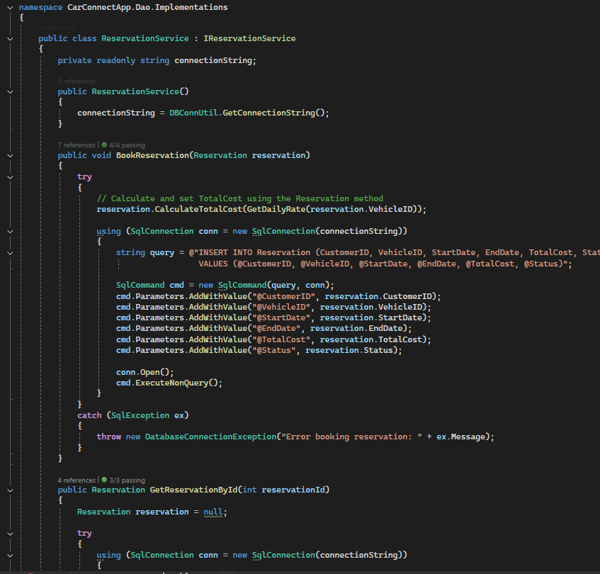

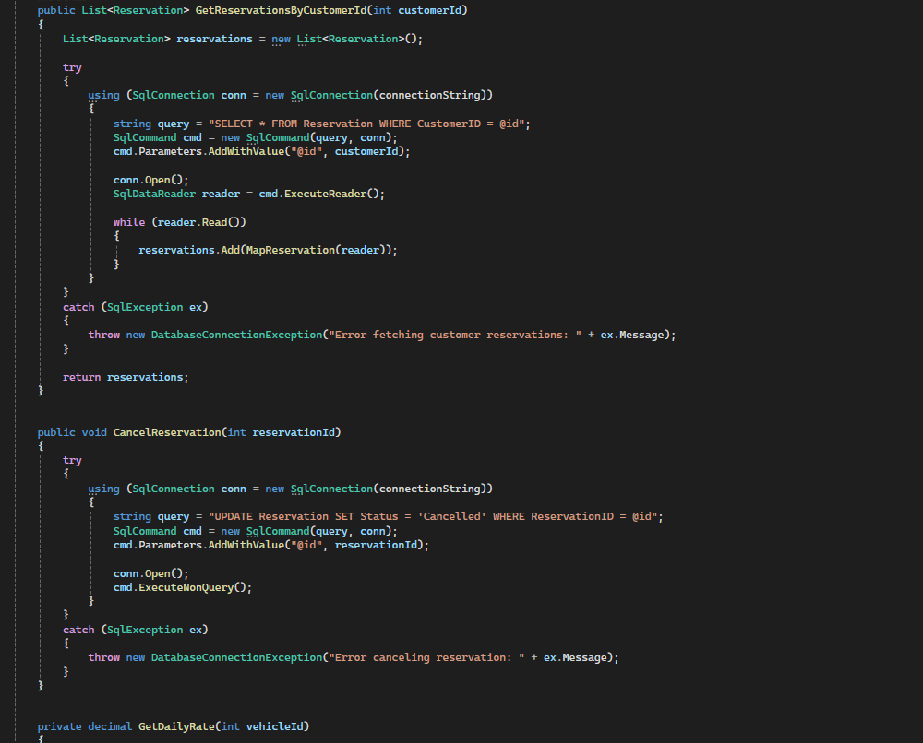

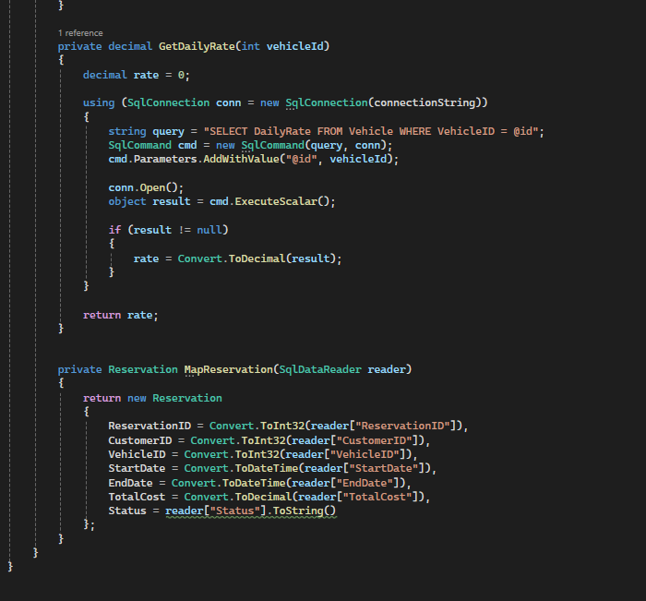

**Exceptions/AdminNotFoundException.cs**

using System;

using CarConnectApp.Exceptions;

namespace CarConnectApp.Exceptions

{

public class AdminNotFoundException : Exception

{

public AdminNotFoundException(string message) : base(message) { }

}

}

**Exceptions/AuthenticationException.cs**

using System;

using CarConnectApp.Exceptions;

namespace CarConnectApp.Exceptions

{

public class AuthenticationException : Exception

{

public AuthenticationException(string message) : base(message)

{

}

}

}

**Exceptions/DataBaseConnectionException.cs**

using System;

using CarConnectApp.Exceptions;

namespace CarConnectApp.Exceptions

{

public class DatabaseConnectionException : Exception

{

// Default constructor

public DatabaseConnectionException() { }

// Constructor that takes a message

public DatabaseConnectionException(string message) : base(message) { }

// Constructor that takes a message and an inner exception

public DatabaseConnectionException(string message, Exception innerException) : base(message, innerException) { }

}

}

**Exceptions/InvalidInputException.cs**

using System;

using CarConnectApp.Exceptions;

namespace CarConnectApp.Exceptions

{

public class InvalidInputException : Exception

{

public InvalidInputException(string message) : base(message) { }

}

}

**Exceptions/ReservationException.cs**

using System;

using CarConnectApp.Exceptions;

namespace CarConnectApp.Exceptions

{

public class ReservationException : Exception

{

public ReservationException(string message) : base(message) { }

}

}

**Exceptions/VehicleNotFoundException.cs**

using System;

using CarConnectApp.Exceptions;

namespace CarConnectApp.Exceptions

{

public class VehicleNotFoundException : Exception

{

public VehicleNotFoundException(string message) : base(message) { }

}

}

**Service/AuthenticationService.cs**

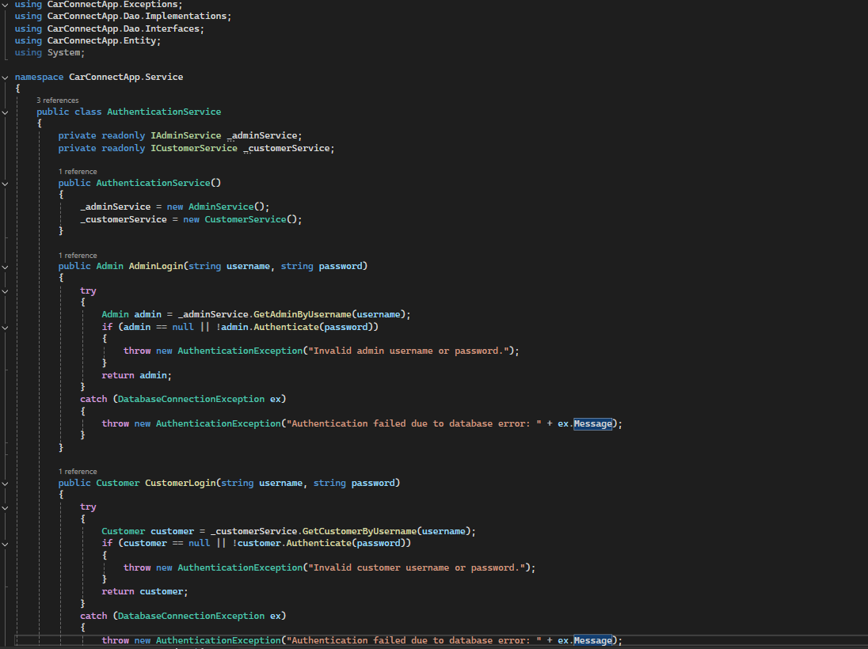

**Service/ReportGenerator.cs**

using CarConnectApp.Exceptions;

using CarConnectApp.Dao.Implementations;

using CarConnectApp.Dao.Interfaces;

//using CarConnectApp.Exceptions;

using CarConnectApp.Entity;

using CarConnectApp.Util;

using Microsoft.Data.SqlClient;

using System;

using System.Collections.Generic;

using System.Linq;

namespace CarConnectApp.Service

{

public class ReportGenerator

{

private readonly IReservationService _reservationService;

private readonly IVehicleService _vehicleService;

private readonly ICustomerService _customerService;

public ReportGenerator()

{

_reservationService = new ReservationService();

_vehicleService = new VehicleService();

_customerService = new CustomerService();

}

public void GenerateReservationHistoryReport()

{

Console.WriteLine("\n--- Reservation History Report ---");

try

{

List<Reservation> allReservations = new List<Reservation>();

// This would ideally fetch all reservations. Assuming a method like GetAllReservations() exists.

// For demonstration, let's assume we iterate through customer IDs or have a direct DAO method.

// Since IReservationService doesn't have GetAllReservations, we'll demonstrate based on customer.

// In a real scenario, you'd add a GetAllReservations() to IReservationService and its implementation.

// Placeholder: For a real report, you'd need a DAO method to get all reservations.

// For now, this just illustrates structure.

Console.WriteLine("Note: A comprehensive 'All Reservations' report would require a GetAllReservations method in IReservationService.");

Console.WriteLine("Displaying reservations by a dummy customer ID (e.g., 1) as an example:");

List<Reservation> sampleReservations = _reservationService.GetReservationsByCustomerId(1); // Example

if (sampleReservations.Any())

{

foreach (var reservation in sampleReservations)

{

Customer customer = _customerService.GetCustomerById(reservation.CustomerID);

Vehicle vehicle = _vehicleService.GetVehicleById(reservation.VehicleID);

Console.WriteLine($"Reservation ID: {reservation.ReservationID}");

Console.WriteLine($" Customer: {customer?.FirstName} {customer?.LastName} (ID: {customer?.CustomerID})");

Console.WriteLine($" Vehicle: {vehicle?.Make} {vehicle?.Model} (Reg: {vehicle?.RegistrationNumber}, ID: {vehicle?.VehicleID})");

Console.WriteLine($" Start Date: {reservation.StartDate.ToShortDateString()}");

Console.WriteLine($" End Date: {reservation.EndDate.ToShortDateString()}");

Console.WriteLine($" Total Cost: ${reservation.TotalCost:F2}");

Console.WriteLine($" Status: {reservation.Status}");

Console.WriteLine("--------------------");

}

}

else

{

Console.WriteLine("No reservations found.");

}

}

catch (DatabaseConnectionException ex)

{

Console.WriteLine($"Error generating reservation history report: {ex.Message}");

}

catch (Exception ex)

{

Console.WriteLine($"An unexpected error occurred: {ex.Message}");

}

}

public void GenerateVehicleUtilizationReport()

{

Console.WriteLine("\n--- Vehicle Utilization Report ---");

try

{

List<Vehicle> allVehicles = _vehicleService.GetAvailableVehicles(); // Assuming GetAvailableVehicles can be repurposed or a GetAllVehicles is added

if (!allVehicles.Any())

{

Console.WriteLine("No vehicles found in the system.");

return;

}

foreach (var vehicle in allVehicles)

{

// For a true utilization report, you'd query reservations for this vehicle

// and calculate the percentage of time it's been reserved over a period.

// For simplicity, we'll just show current availability.

string availabilityStatus = vehicle.Availability ? "Available" : "Not Available (currently rented)";

Console.WriteLine($"Vehicle: {vehicle.Make} {vehicle.Model} (Reg: {vehicle.RegistrationNumber})");

Console.WriteLine($" Current Availability: {availabilityStatus}");

// To get full utilization, you'd need to query past reservations for this vehicle

// SELECT COUNT(*) FROM Reservation WHERE VehicleID = @VehicleID AND Status = 'completed'

Console.WriteLine("--------------------");

}

}

catch (DatabaseConnectionException ex)

{

Console.WriteLine($"Error generating vehicle utilization report: {ex.Message}");

}

catch (Exception ex)

{

Console.WriteLine($"An unexpected error occurred: {ex.Message}");

}

}

public void GenerateRevenueReport()

{

Console.WriteLine("\n--- Revenue Report ---");

try

{

// This would sum up TotalCost from completed reservations.

// Assuming a method to get all completed reservations or total revenue from DAO.

// For demonstration, let's sum from a hypothetical list or directly query the database.

decimal totalRevenue = 0;

using (SqlConnection conn = new SqlConnection(DBConnUtil.GetConnectionString()))

{

string query = "SELECT SUM(TotalCost) FROM Reservation WHERE Status = 'completed'";

SqlCommand cmd = new SqlCommand(query, conn);

conn.Open();

object result = cmd.ExecuteScalar();

if (result != DBNull.Value && result != null)

{

totalRevenue = Convert.ToDecimal(result);

}

}

Console.WriteLine($"Total Revenue Generated: ${totalRevenue:F2}");

Console.WriteLine("--------------------");

}

catch (DatabaseConnectionException ex)

{

Console.WriteLine($"Error generating revenue report: {ex.Message}");

}

catch (Exception ex)

{

Console.WriteLine($"An unexpected error occurred: {ex.Message}");

}

}

}

}

**Util/DBConnUtil.cs**

using CarConnectApp.Exceptions;

using CarConnectApp.Util;

using Microsoft.Data.SqlClient;

using System;

using System.IO;

namespace CarConnectApp.Util

{

public static class DBConnUtil

{

private static string connectionString;

static DBConnUtil()

{

// This static constructor runs once when the class is first accessed.

// It tries to load the connection string from db.properties.

// In a real application, you might use app.config/web.config for connection strings.

try

{

connectionString = DBPropertyUtil.GetConnectionString("db.properties");

}

catch (FileNotFoundException ex)

{

throw new DatabaseConnectionException("Database property file not found: " + ex.Message);

}

catch (Exception ex)

{

throw new DatabaseConnectionException("Error loading database connection string: " + ex.Message);

}

}

public static string GetConnectionString()

{

if (string.IsNullOrEmpty(connectionString))

{

// This case should ideally not be hit if the static constructor runs correctly,

// but it's a fallback for robust error handling.

throw new DatabaseConnectionException("Database connection string is not initialized.");

}

return connectionString;

}

public static SqlConnection GetDBConnection()

{

try

{

return new SqlConnection(GetConnectionString());

}

catch (Exception ex)

{

throw new DatabaseConnectionException("Failed to create database connection object: " + ex.Message);

}

}

}

}

**Util/DBPropertyUtil.cs**

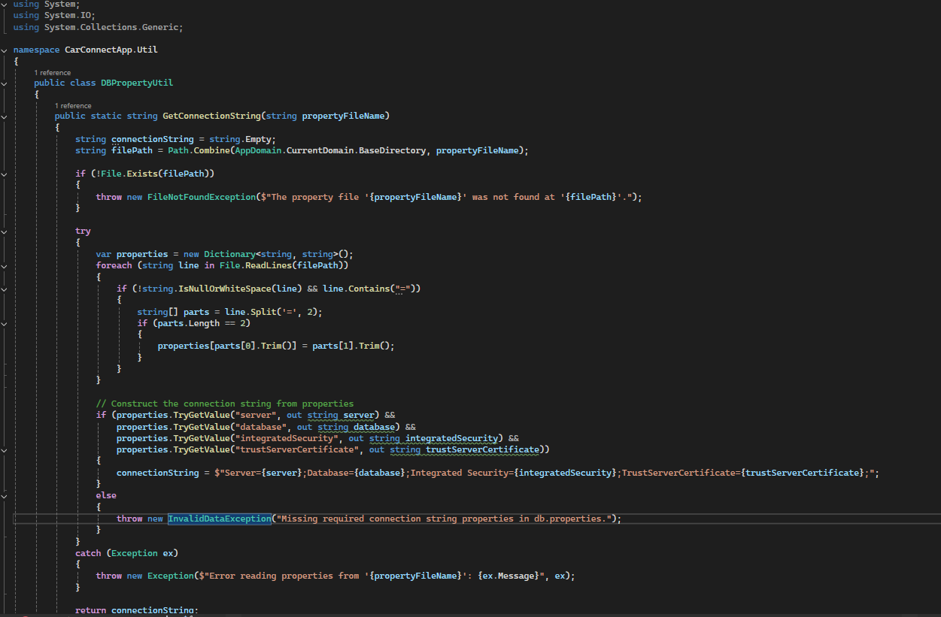

**Db.Properties**

server=(localdb)\MSSQLLocalDB

database=CarConnect

integratedSecurity=True

trustServerCertificate=True

**Program.cs**

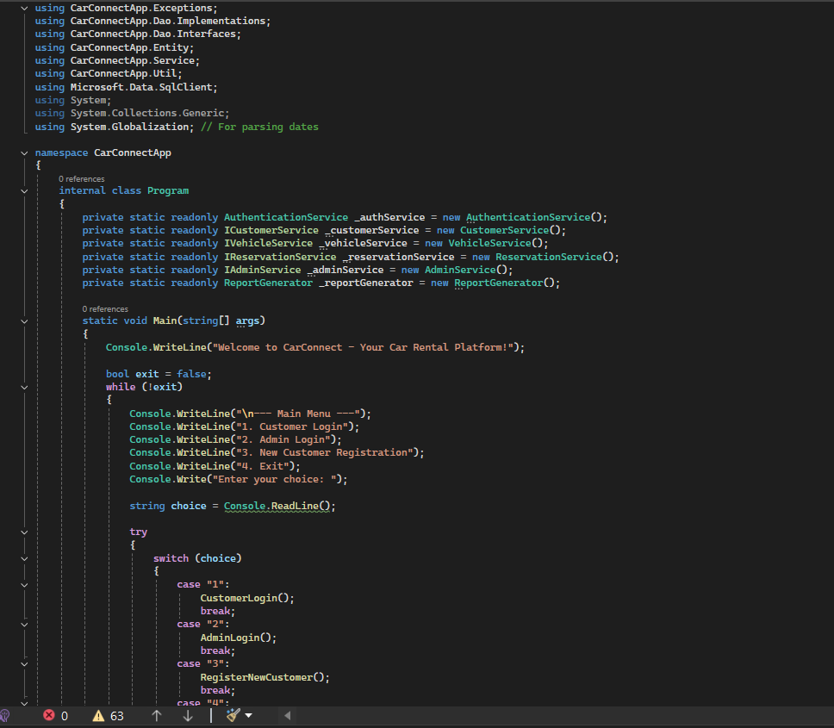

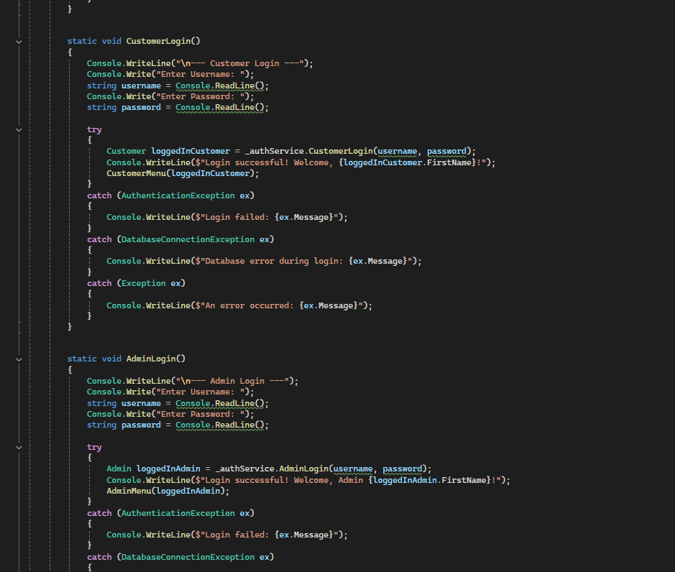

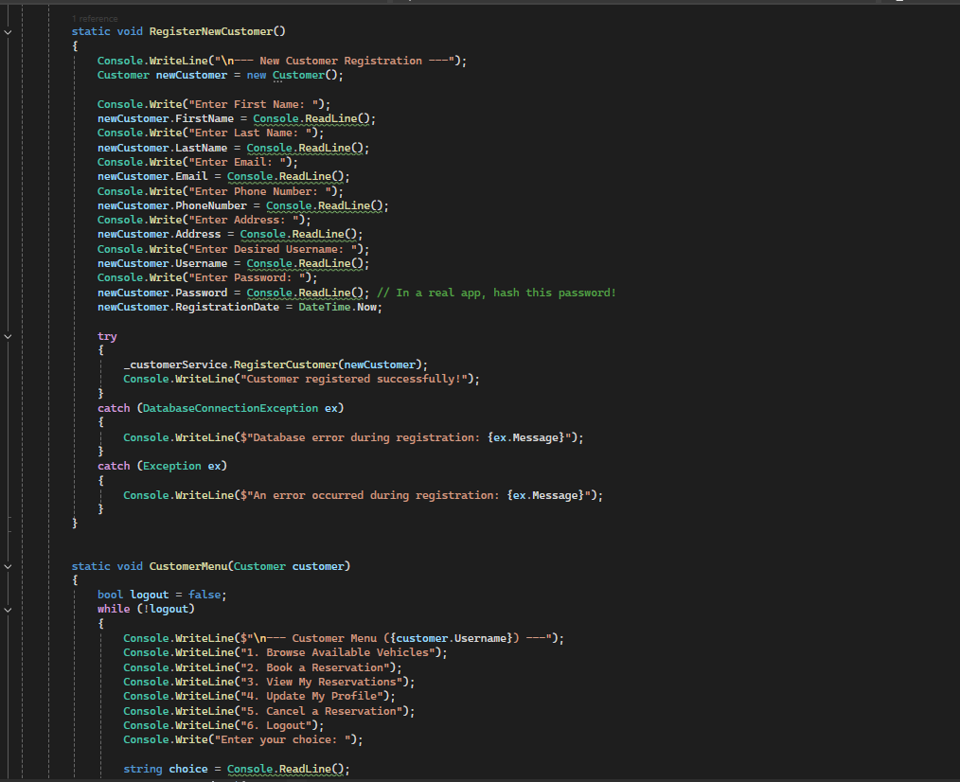

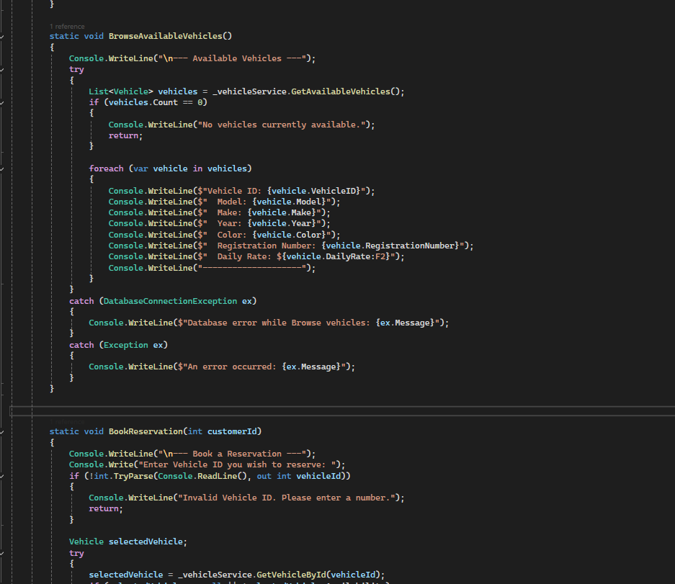

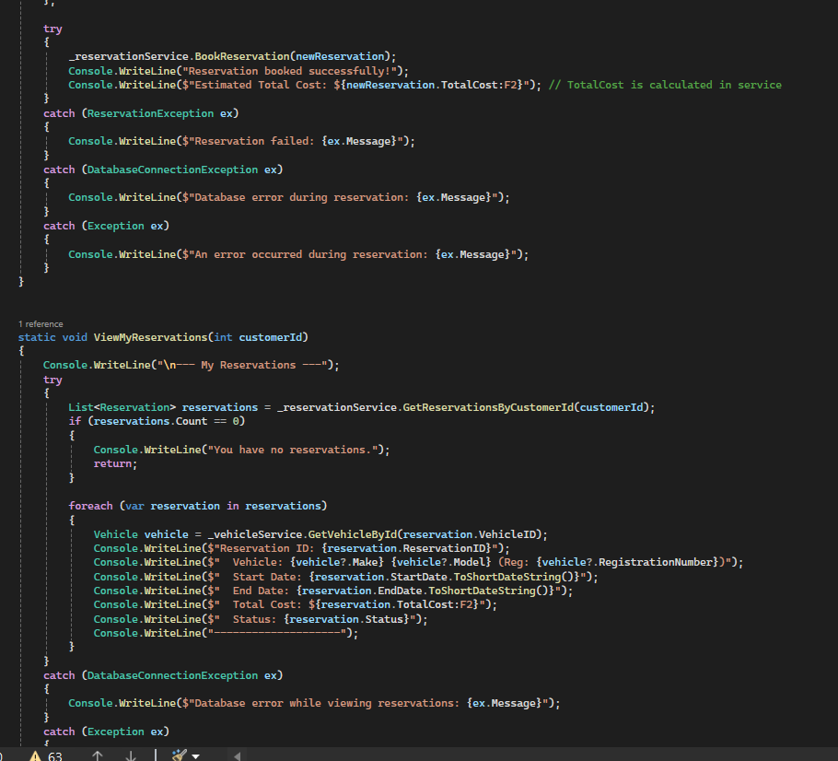

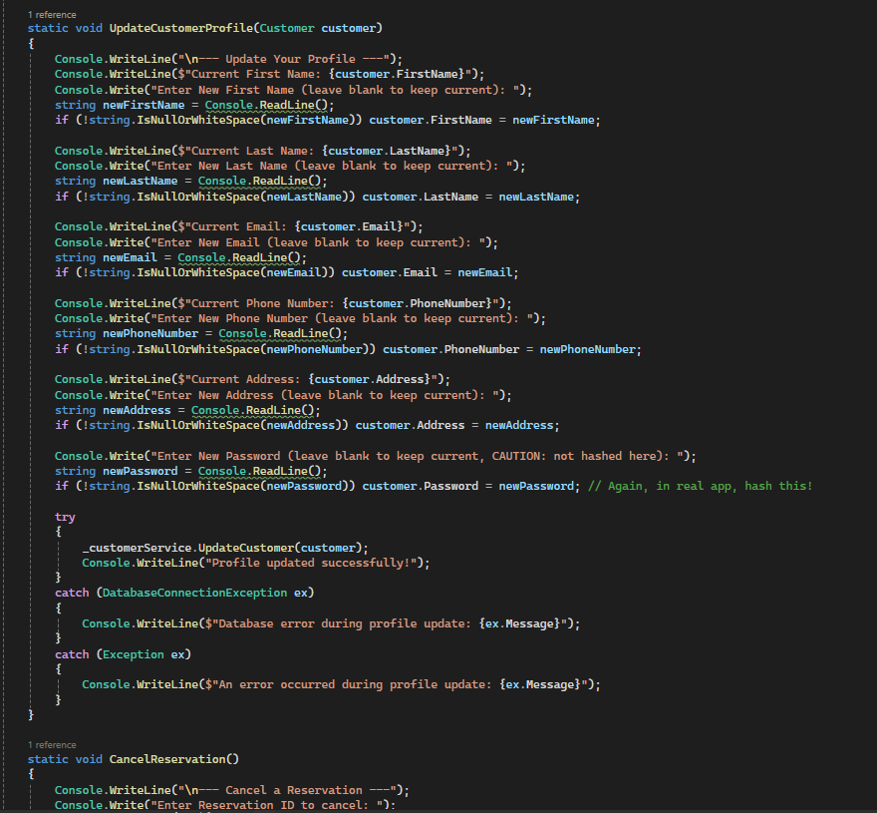

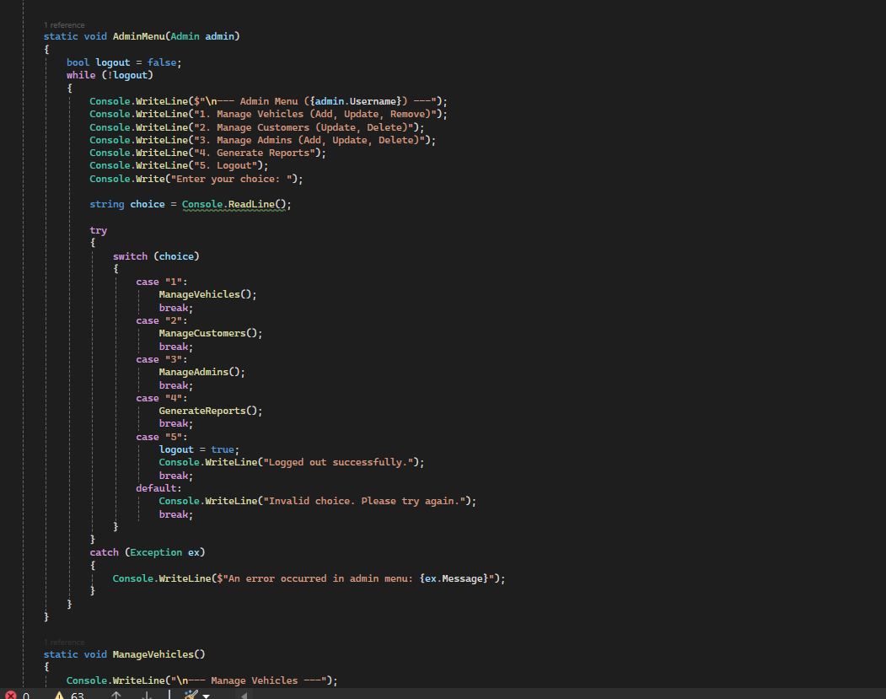

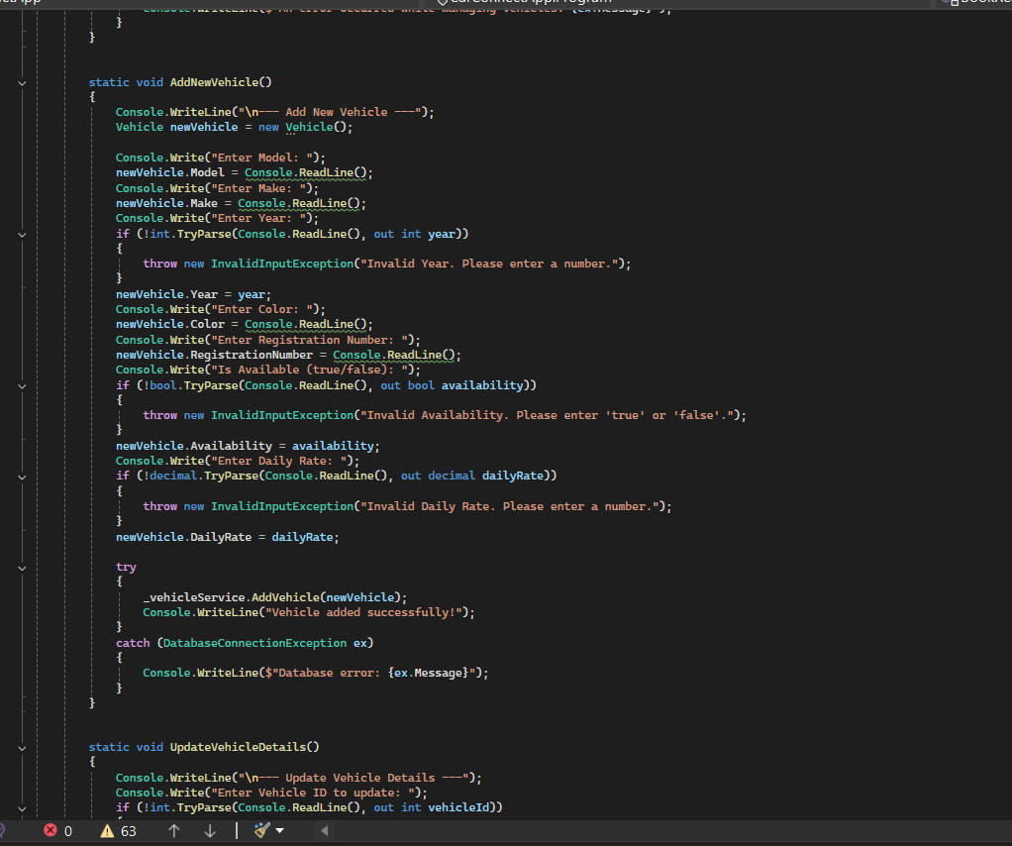

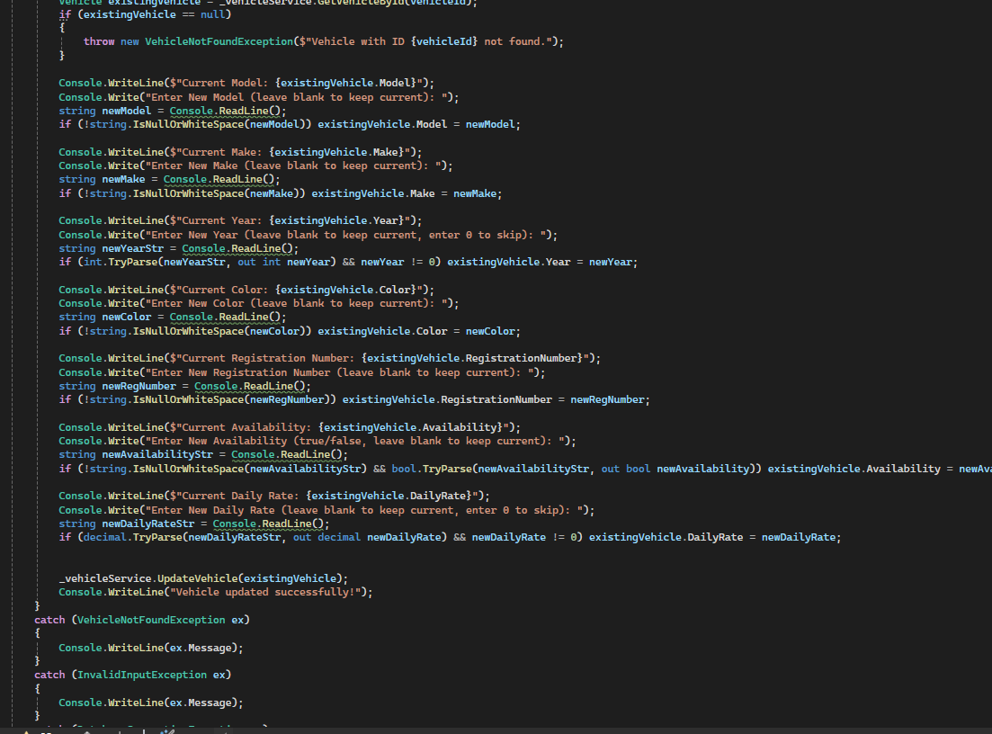

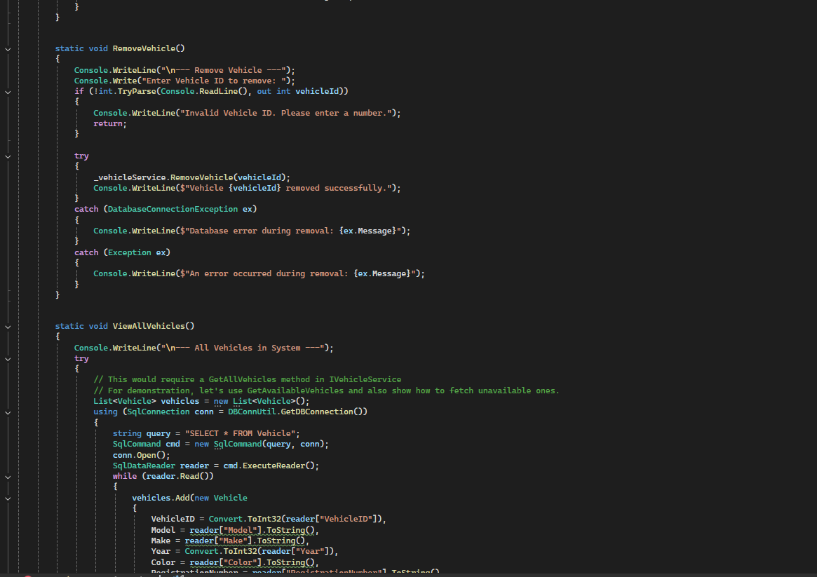

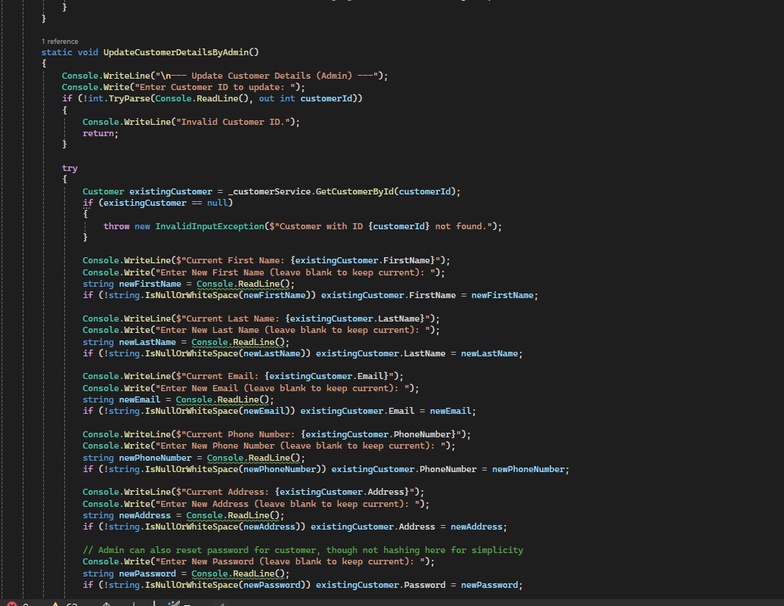

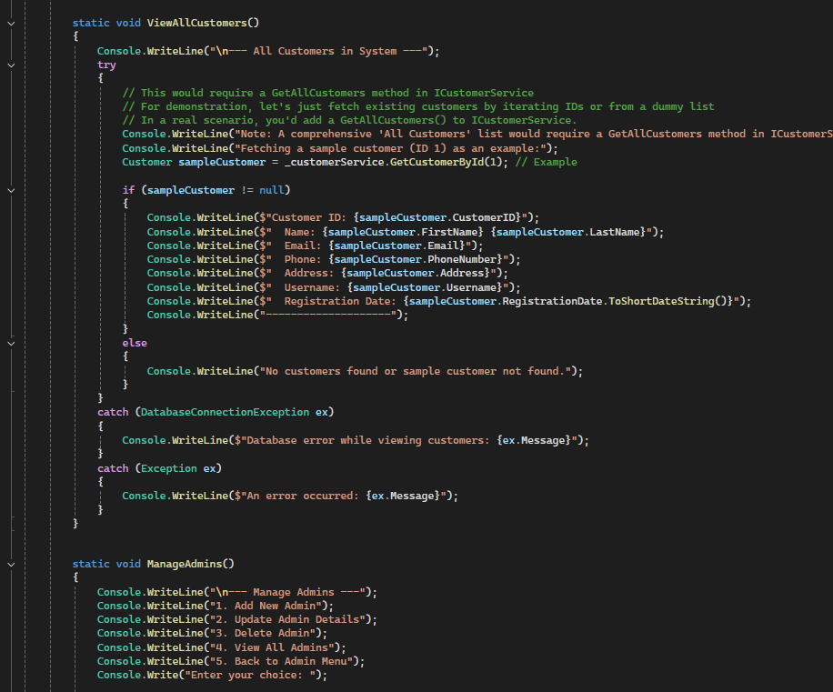

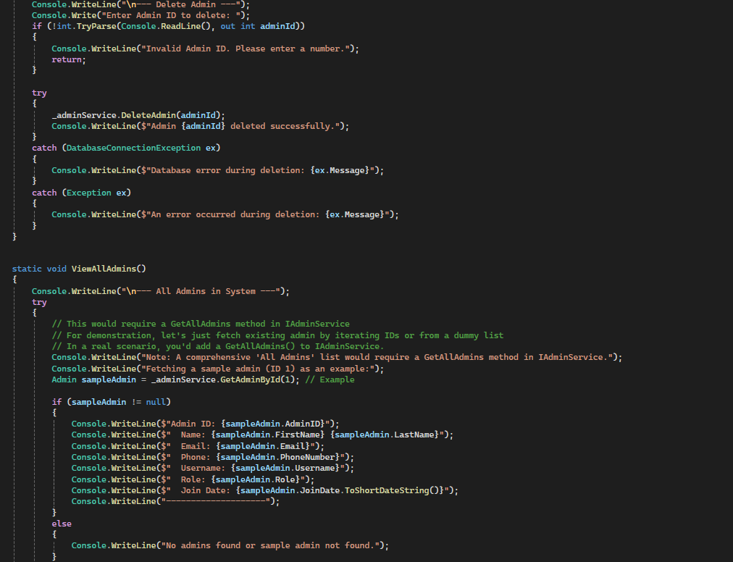

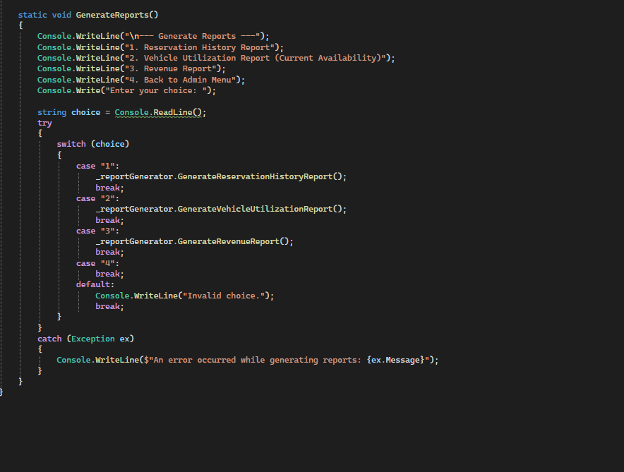

**CarConnect.Tests/AdminServiceTest.cs**

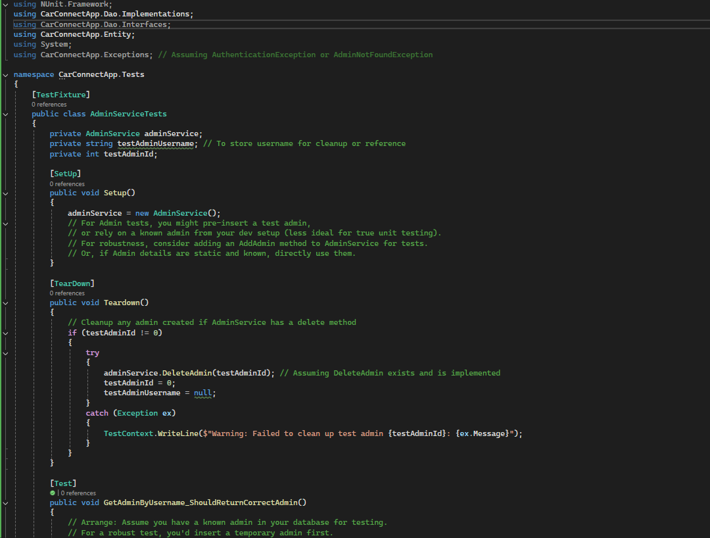

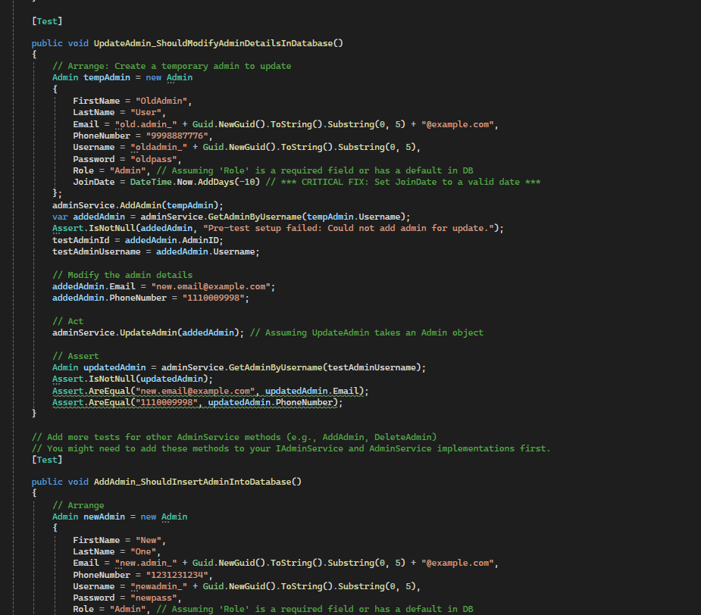

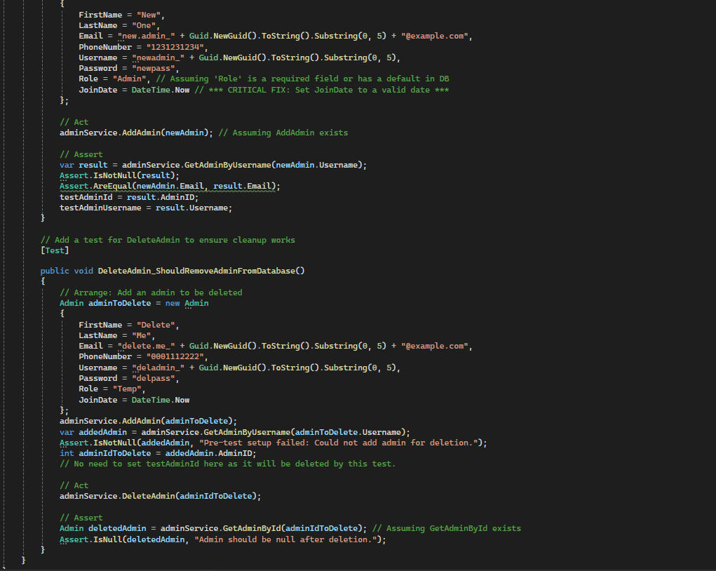

**Carconnect.Tests/VehicleServiceTest.cs**

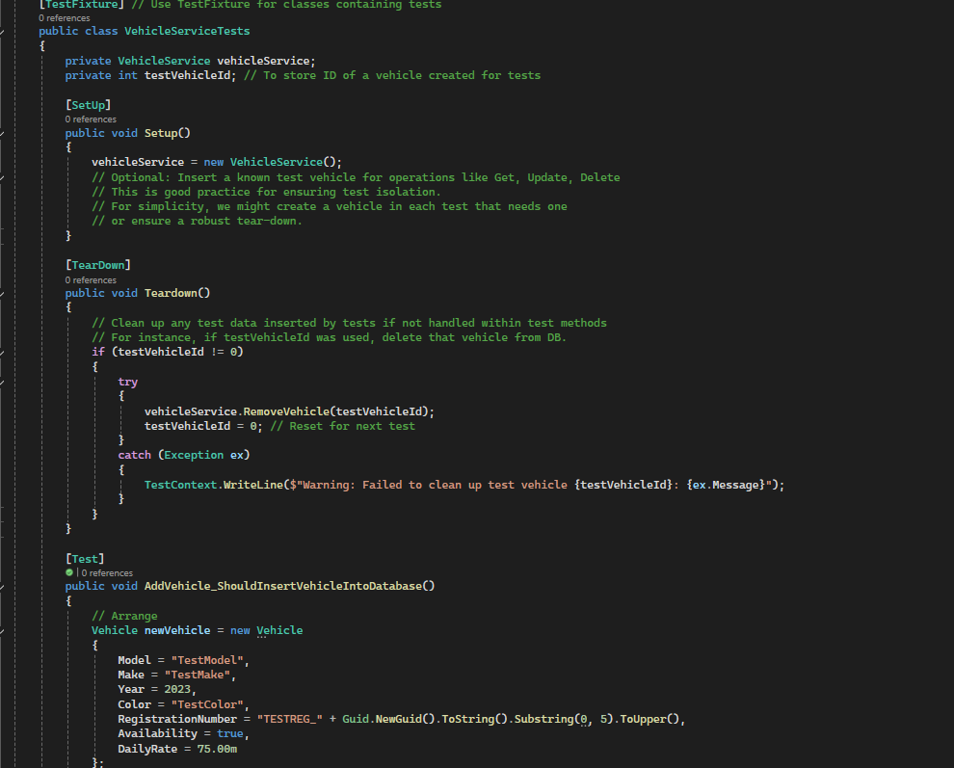

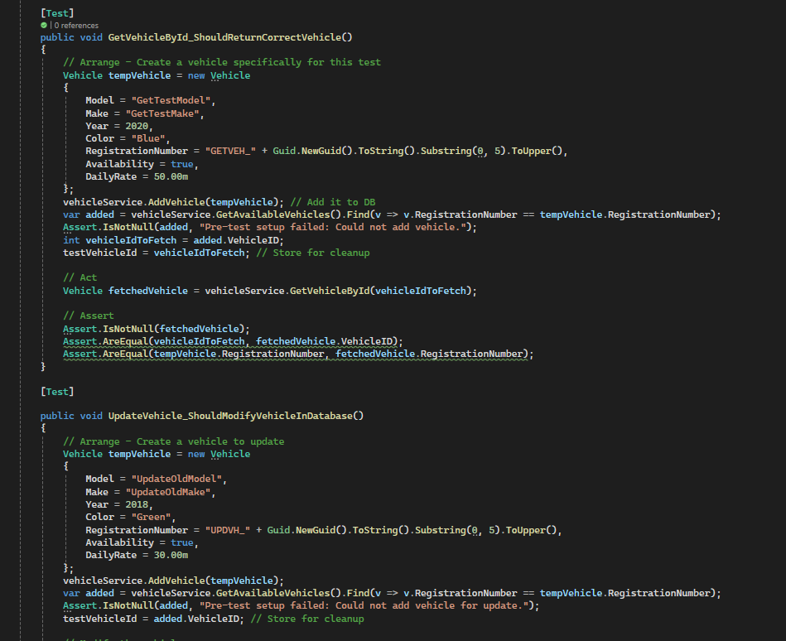

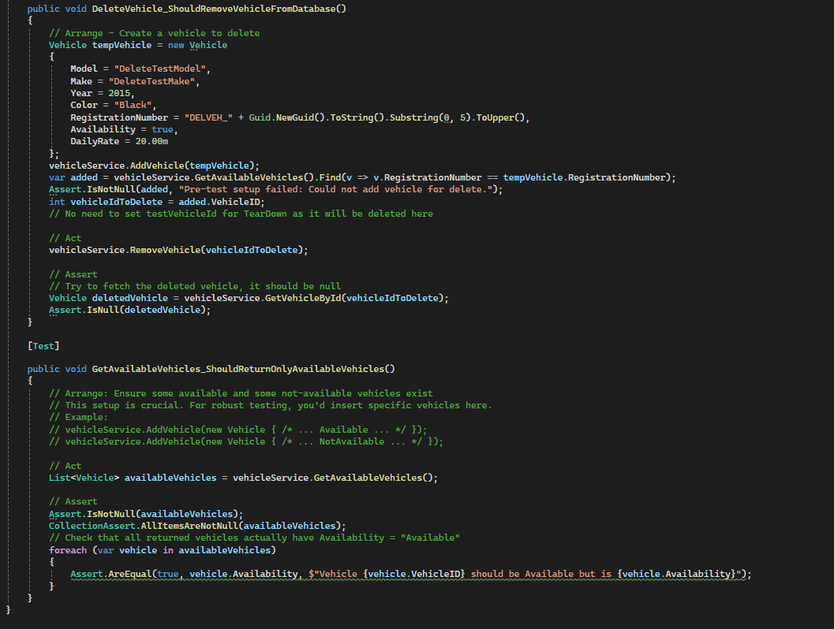

**CarConnect.Tests/CustomerServiceTest.cs**

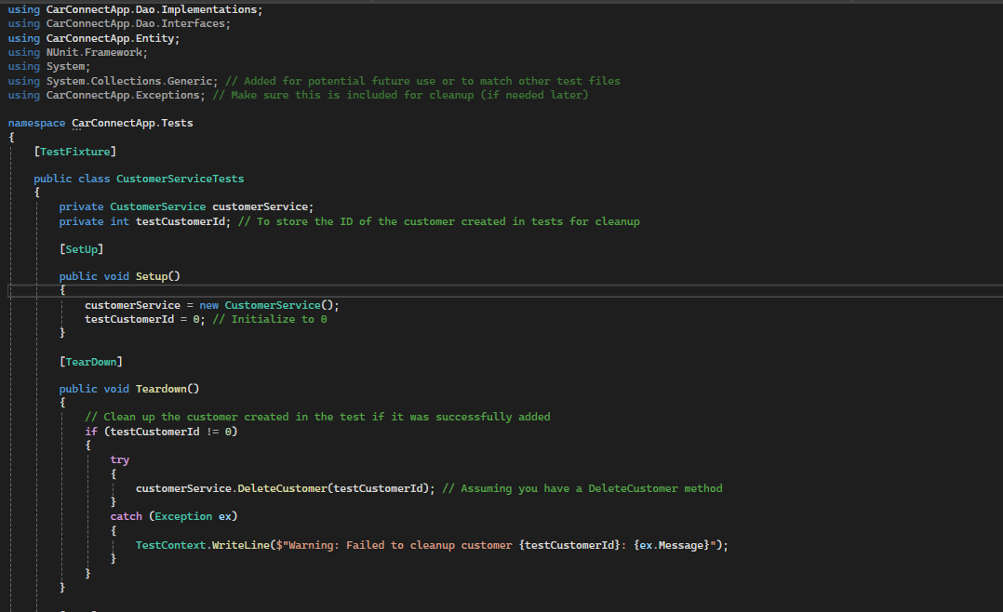

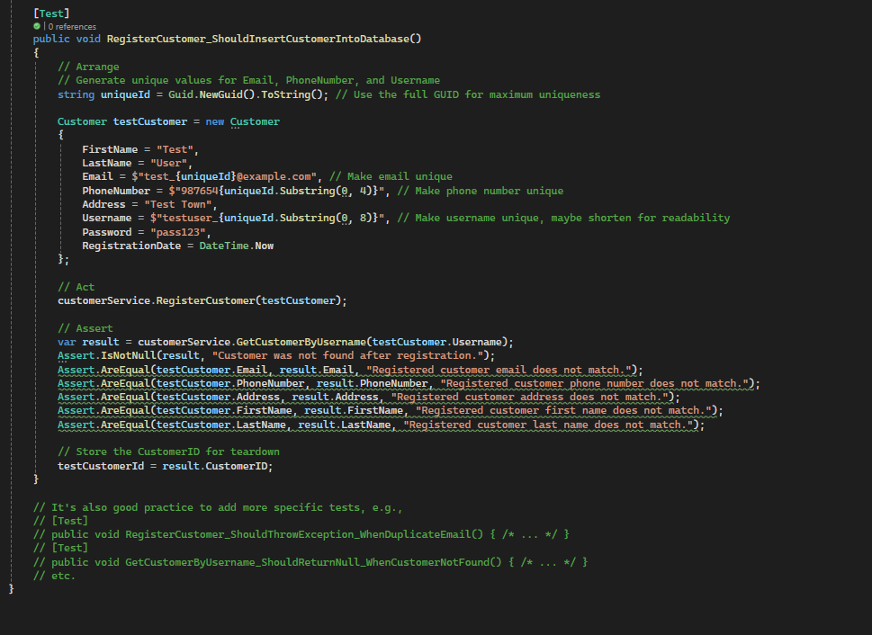

**CarConnect.Tests/ReservationServiceTest.cs**



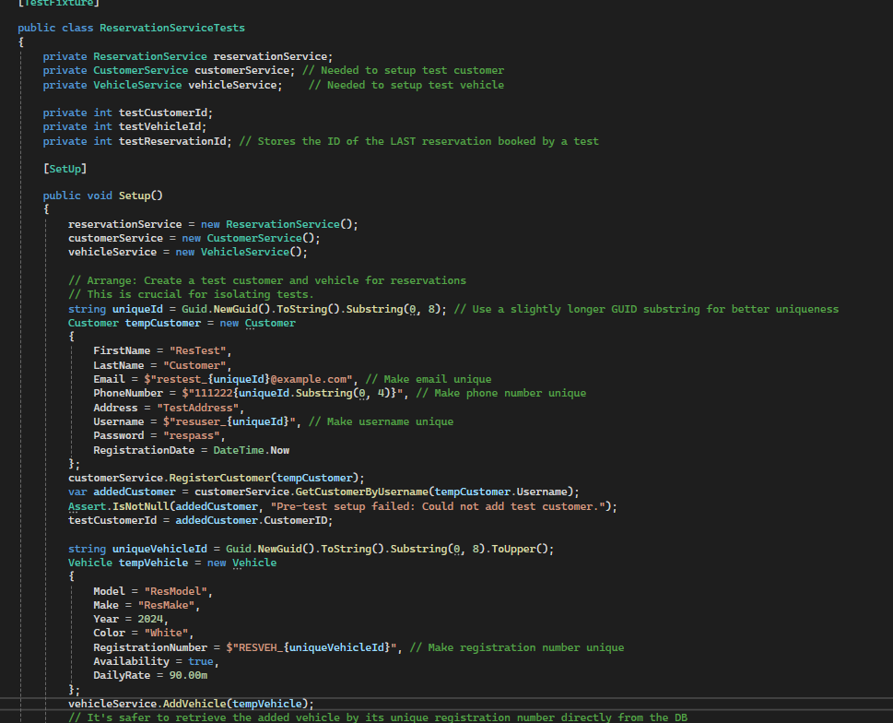

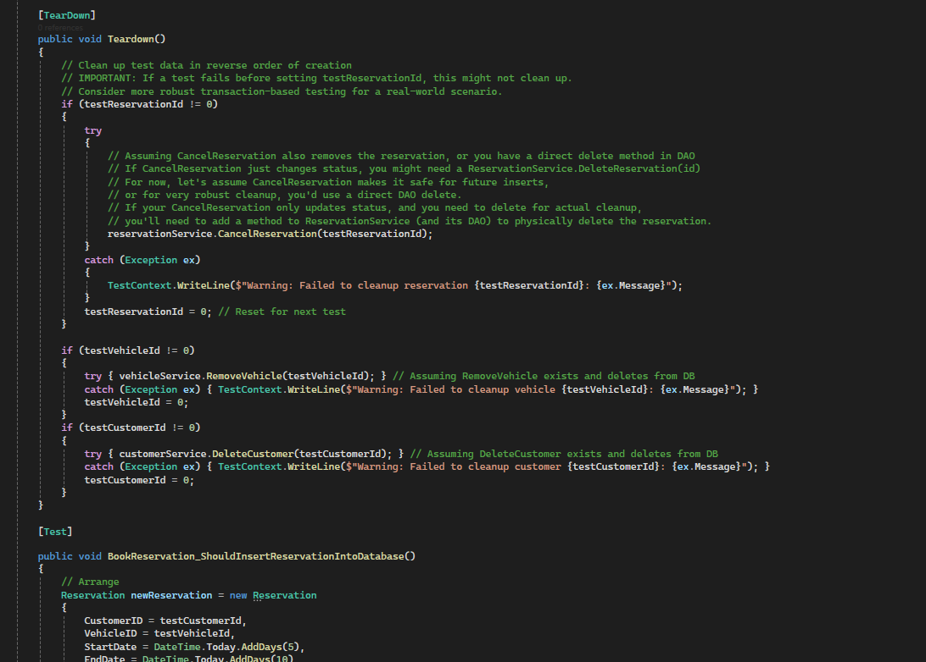

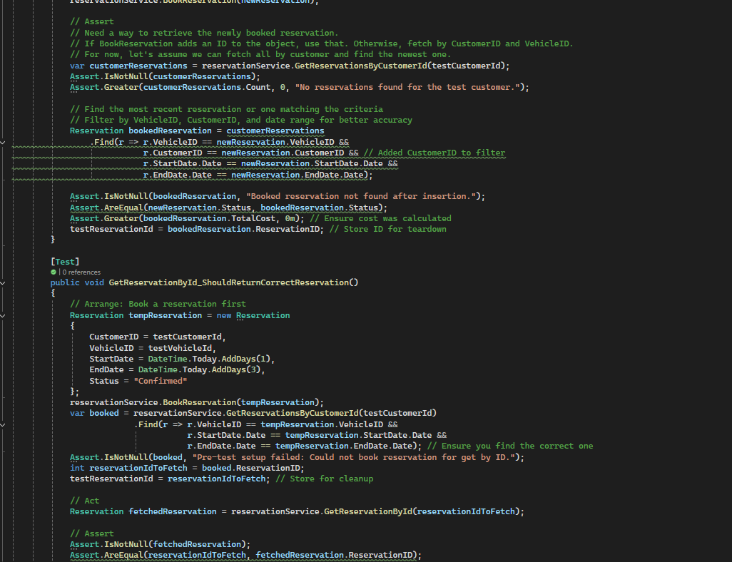

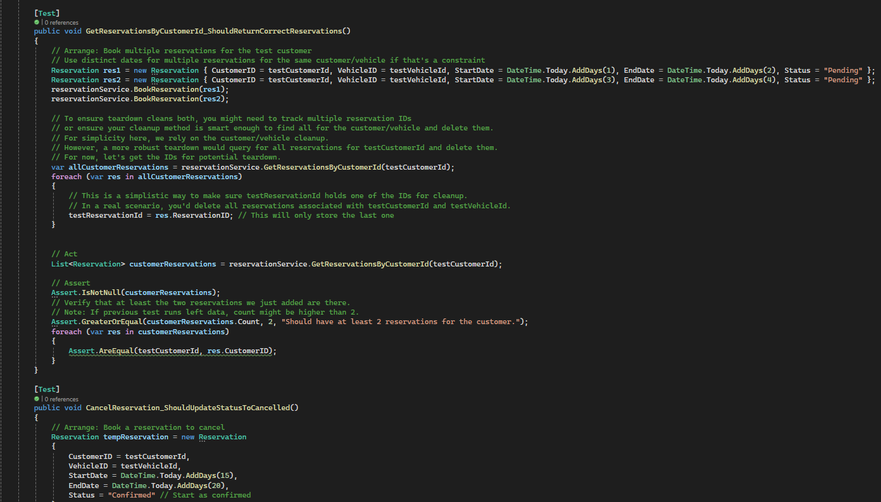

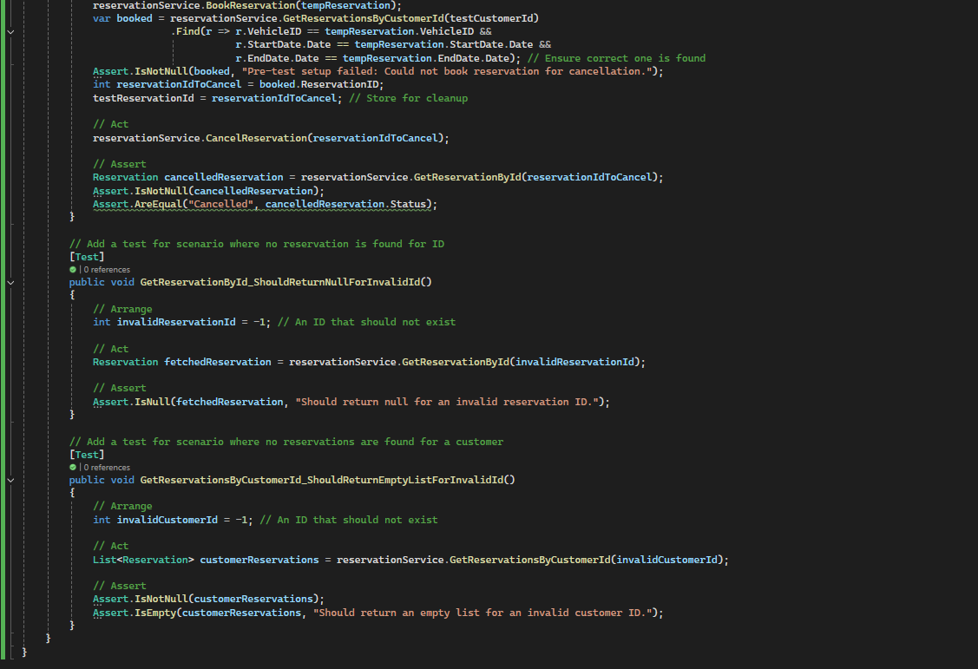

**Output:**

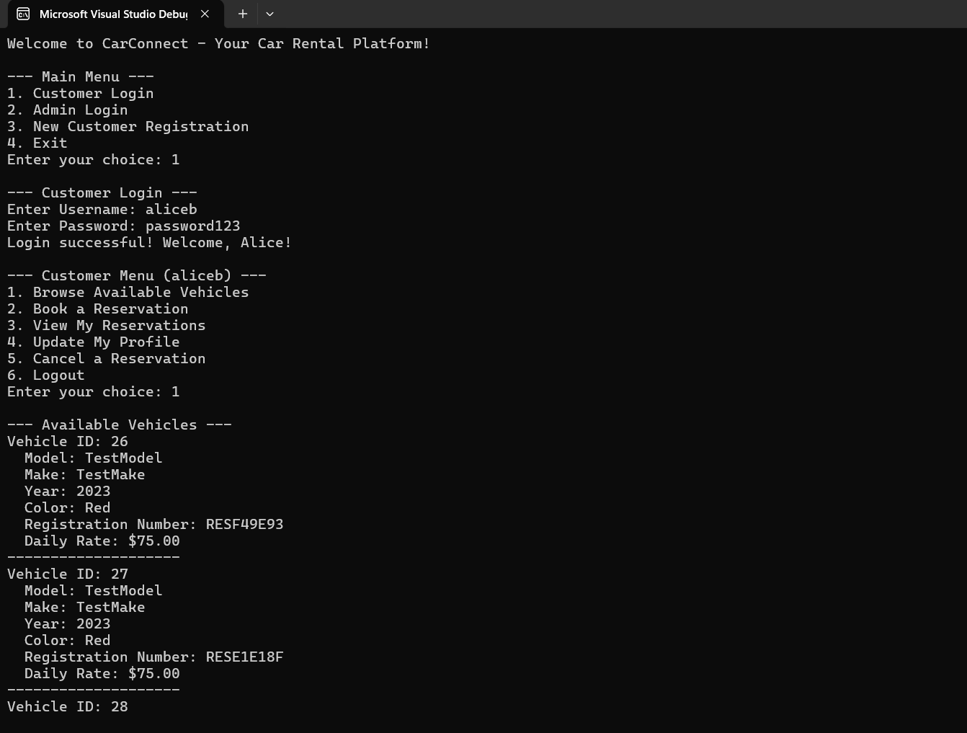

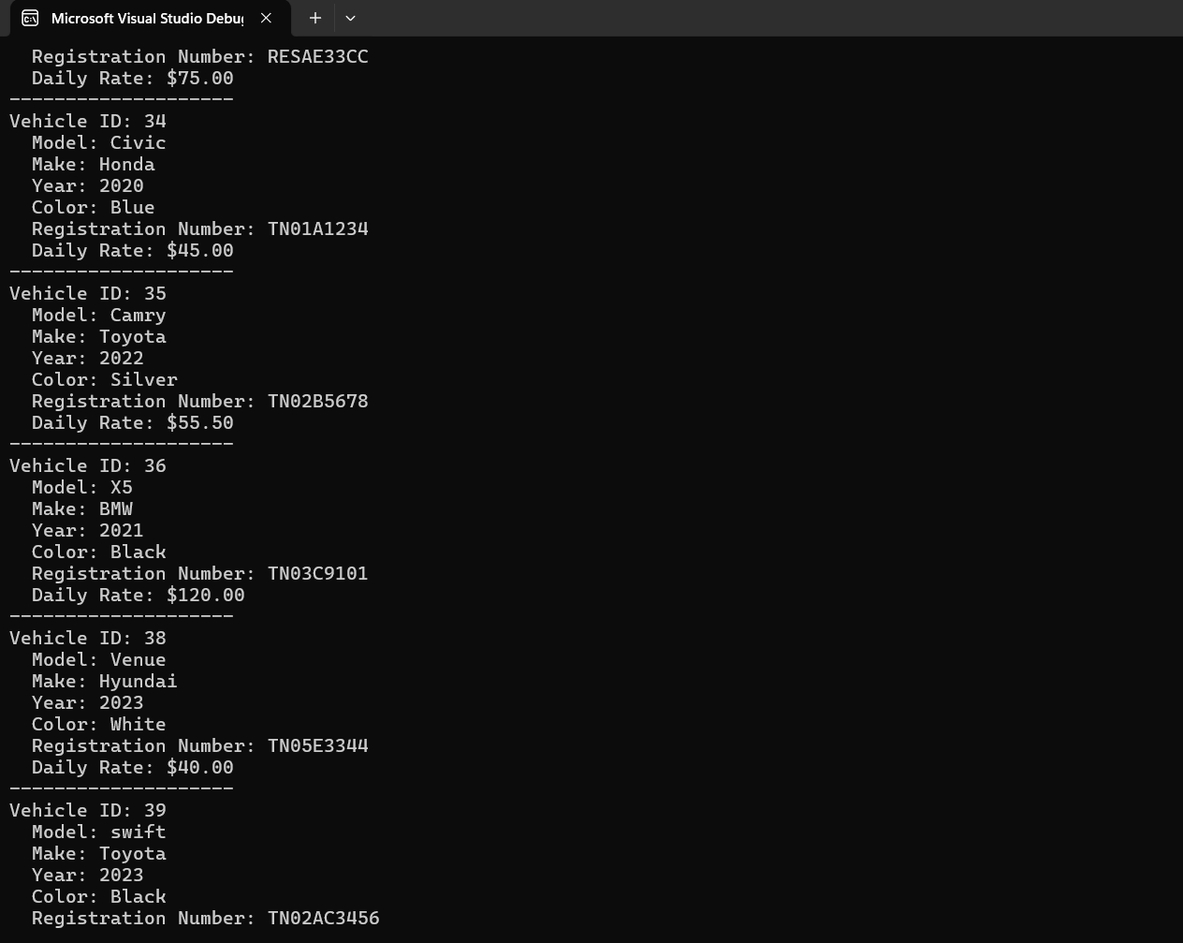

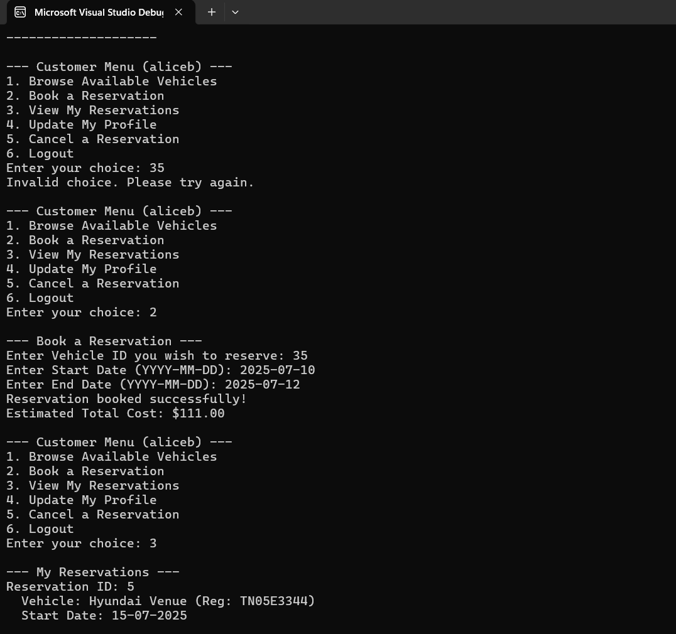

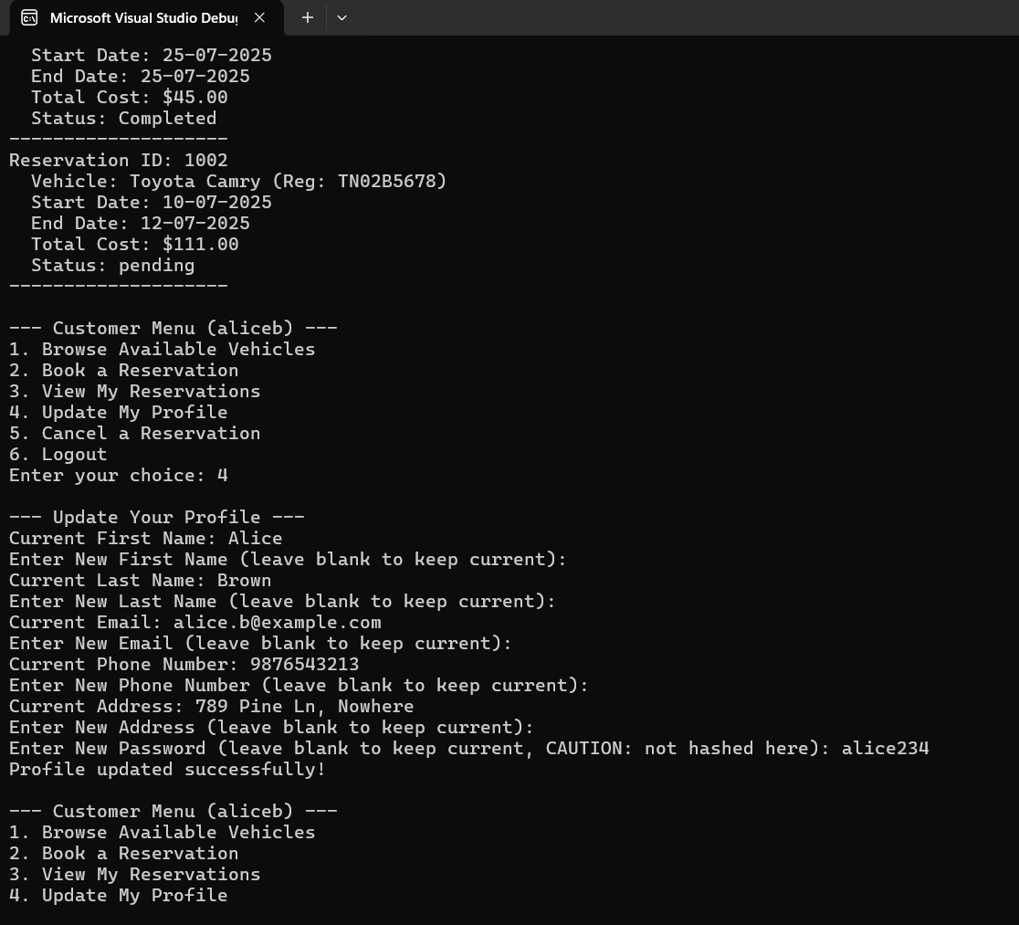

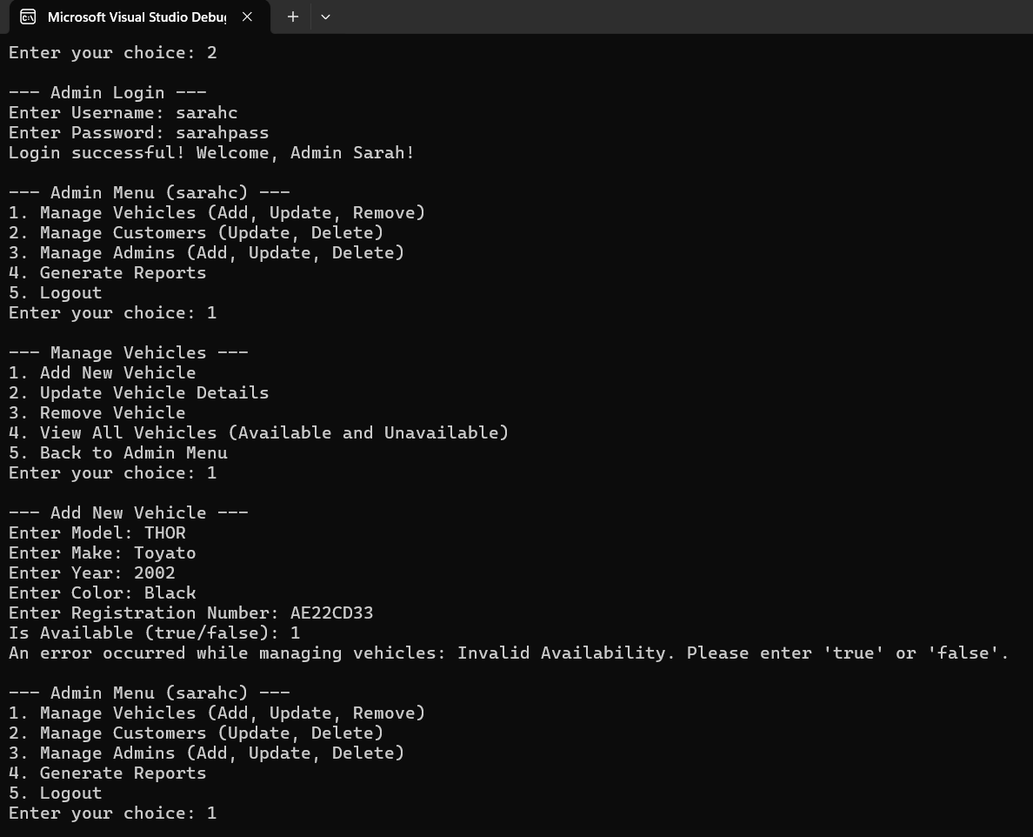

**Testing Result:**

